**Configuring Jenkins for running Jenkins Jobs:**

Now open Jenkins and go to Global Tool Configuration and set up the paths for JDK and Maven.

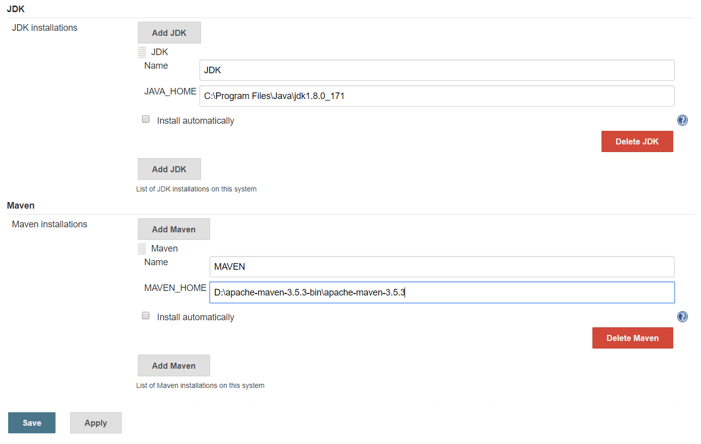

Since JDK is installed in C driver under program files under Java, I have provided the path.

Similarly provide the path for Maven as well. Once you enter both the details save it.

Now create a new job in Jenkins. Click on either New Item or “Create new jobs” on the home page.

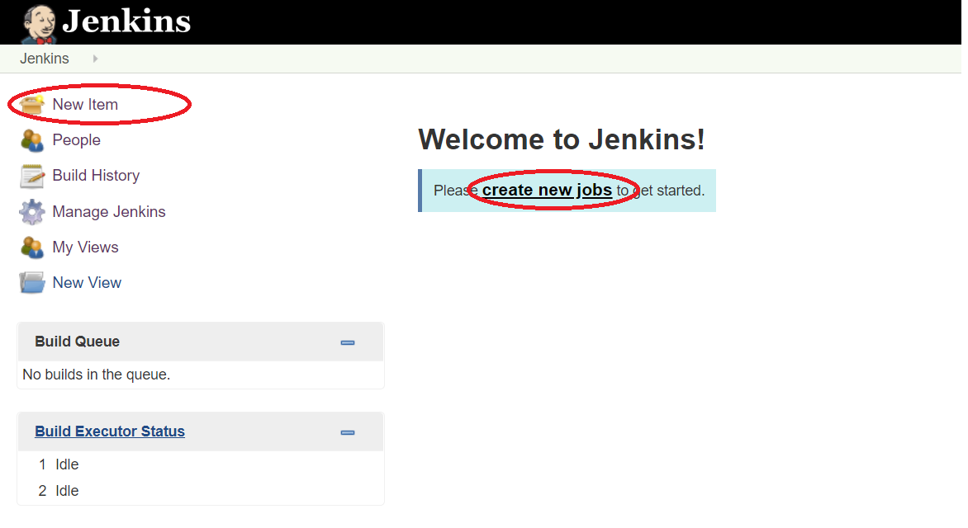

Then it asks for the job name. Enter any name you want and select Free Style Project. I have enter it as FirstProject.

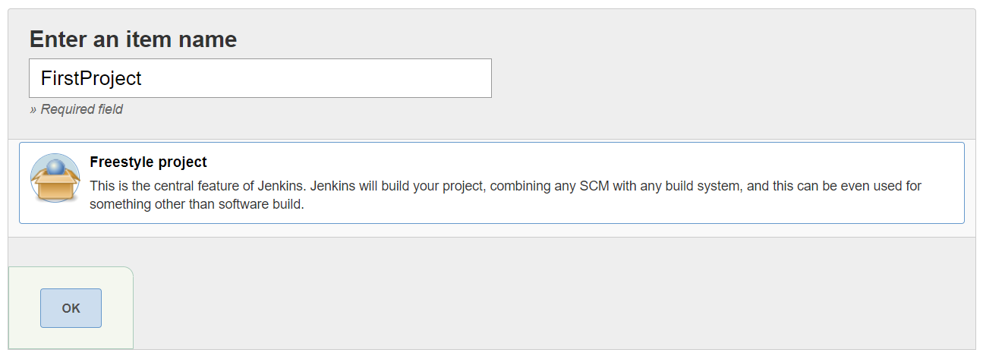

In order to set up the project which is in our local machine, under GENERAL tab click on Advanced button and select “Custom Workspace” and enter the url of the project. We need to give the url until where the POM.xml is located.

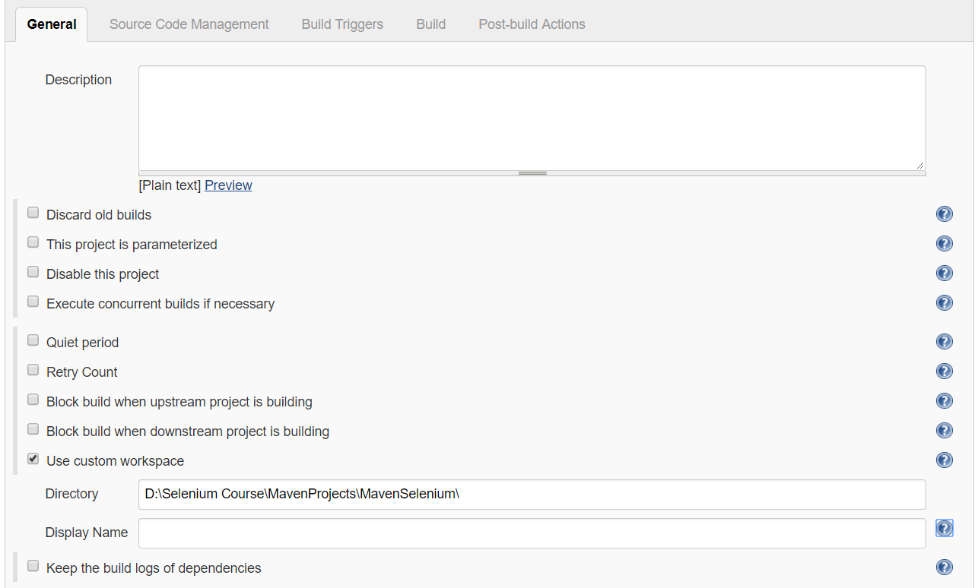

You can get the directory where the pom.xml is, by righ clicking on the pom.xml and click on properties in Eclipse.

Note: Instead of putting the path there, you can copy the project into “.jenkins” folder (this folder will be created once Jenkins is installed).

Then you can provide the url as ${JENKINS_HOME}/ProjectName

Under “Build” section click on “Add Build Step” and select “Invoke Top-Level Maven Targets”. You can select the maven version here and enter the goal as “test”. You don’t need to provide mvn command here. If you have used profiles in Maven pom.xml and if you want to run only one profile, then you can use it like test -PRegression and here P means profile.

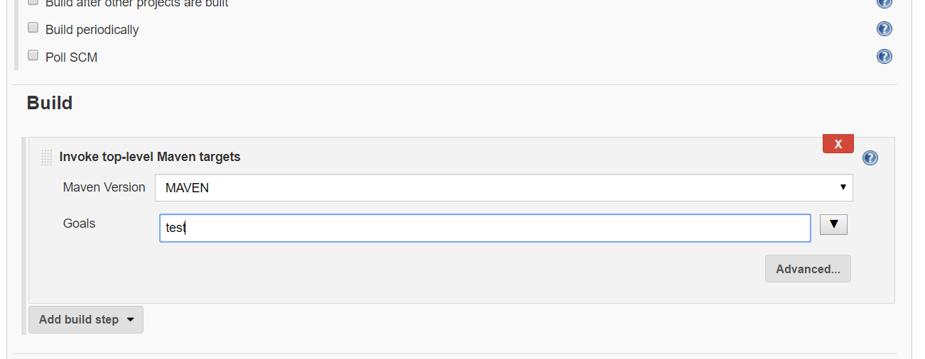

Now after saving, if you are on the home page you can run the project manually by clicking on the alarm clock image. If you are with in the job page, you can run the job by cliking “Build Now” on the left menu.

On the Home Page:

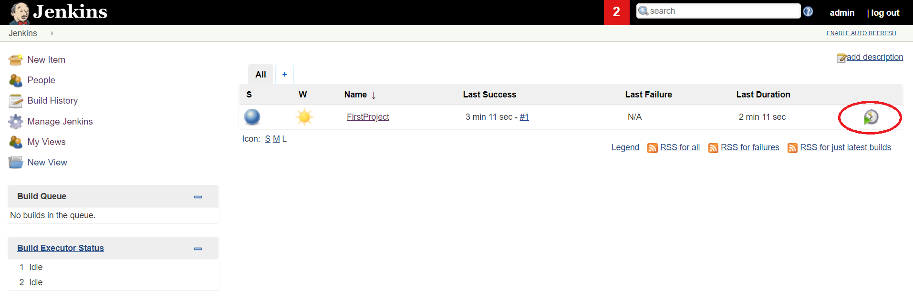

On the Job Page:

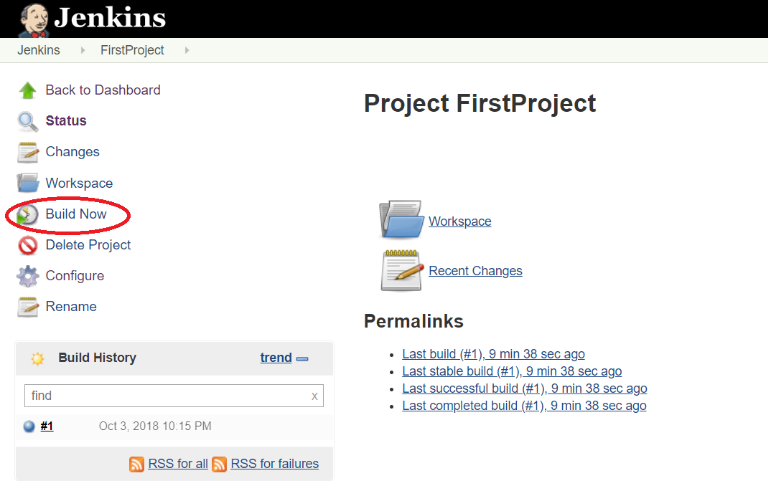

Reports: Once the tests are run through TestNG, in eclipse under “target” folder, under surefire-reports you will find index.html file. Right click, click on properties and select the path and open it in any browser and you will see the results.